Minutes of Somerford Keynes Parish Council Meeting
Village Hall, 10th February 2025

Present: Cllr A. Clark (AC), Cllr J. Whitwell (JW), Cllr M. Keegan (MK), Cllr N. Hunt (NH), Cllr M.H-Oldland (MHO)

Also present: Clerk K. Holdsworth (KH), M Wilding (Village Lake), three members of Cotswold Lake Trust and five member of the public

1. Apologies
Cllr G. Valentine (GV), Hilary Collins (HC), CDC Cllr M McKeown (MM), CC Cllr L Spivey (LS)

2. Declaration of Interest
Cllr N. Hunt (NH), Cllr M.H-Oldland (MHO), Cllr M Keegan (MK) & Cllr J Whitwell (JW)

3. Public Session
Nothing raised.

4. Approval of Minutes of January 13th 2024 Meeting
Proposed JW, seconded MK

5. Report from County Cllr L. Spivey
There is no report from Cllr L Spivey this month.

6. Report from District Cllr M.McKeown
There is no report from Cllr M McKeown this month.

7. Report from M Wilding Village Lake
Village Lake report in Appendix One.

8. Matthew Millet Cotswold Lake Trust
The following matters were raised and discussed.

8.1 Following a couple of summers of poor weather the Trust has been running a significant annual financial deficit. Much of their income comes from Cotswold Country Park & Beach so poor weather correlates to lower attendance and associated revenue.
8.2 As such they need to find additional funding sources. One they are looking at is mini golf and refreshments at Neigh Bridge. This is in the early stages of planning, the PC explained that whilst we understand the need to look at new revenue sources the community’s issues with Neigh Bridge have been around parking in the road (whilst the car park remains relatively empty) and litter and asked whether these could be considered in conjunction with any additional activities.
8.3 The footpath running parallel to the Spine Road at Lake 32 is badly eroded and needs repairs. The Trust is seeking support from a variety of stakeholders to address this. Whilst most of this is in Wiltshire and Ashton Keynes Parish the PC agreed to support this where we can given that this section of path is widely used by our residents.
8.4 MK pointed out the considerable noise heard in Shorncote on busy days at Cotswold County Park & Beach which particularly comes from users of the inflatable structure on the lake.
8.5 Matthew was invited to the PC AGM on May 9th.

9. Actions from Previous Meeting

9.1 Extending Footpath at North End of Village
NH has engaged with several Streetworks Accredited suppliers to obtain costs for extending the footpath at the north of the village from Elm View to Field Farm. To date one quotation has been received which is around £57k for a tarmac path and £45k for a
self binding gravel one.

Should this be pursued the PC would likely seek funding contributions from the Sculpture Park and Field Farm based businesses.

Action: AC to write to Sculpture Park to ascertain their level of interest.
Action: NH to continue to seek additional quotations and engage with Field Farm owners.

9.2 Defibrillator
The batteries and pads for the new Village Hall defibrillator have been installed.

9.3 Lower Mill Estate Support
JW has engaged with Andrew Bonner of LME who has agreed to do some tidying up of the Water Lane hedge as well as cutting brambles and mulch and fixing the owl box at the Village Lake. This is much appreciated.

9.4 Tree Debris
KH has written to GCC regarding the tree debris on the verge between Mill Lane and Neigh Bridge, they have responded and are looking into it

10. Matters Discussed

10.1 Speed Control at North End of Village
As previously minuted, the only option available is to pay £15k for a Traffic Regulation Order to move the 30mph sign. Parishioner feedback received is all in support of the PC’s decision not to pursue.

10.2 Flooding
MK reported positive progress in that work has now started on the ditches around Shorncote by Hills Quarry. Water is now flowing freely though there are still more works to be completed.
Action: MK to retain a watching brief.
Action: HC to provide updates on Spine Road grips clearance, Neigh Bridge Environment Agency kiosk and drainage mapping software.

10.3 Finance and Governance
10.3.1 Standing Orders, Code of Conduct and Financial Regulations
These have been reviewed by the Parish Council and will be adopted.
Action: KH to have them added to SK website.

10.3.2 IT Security
KH has reviewed options and costs and the PC agreed to move Bitdefender at £17.49 pa instead of remaining with McAfee whose renewal was £79.99 pa.
Action: KH to subscribe.

10.4 Dates for Diary
The Village Litter Pick will be held on Saturday 29th March 2025
The AGM will be held on Friday 9th May 2025.

11. Community Infrastrucure Levy Projects

11.1 Village Hall Energy and Infrastructure Upgrade
This is ongoing and works need to be completed in February. The EV charger is now installed.

11.2 Bus Shelter and Notice Board
Hard standing area will be installed on March 17th and the shelter will be erected during week commencing March 31st.
Three quotes have been obtained for a notice board. The PC voted to proceed with the proposal from Lance Heal Joinery as theirs was the most competitive (£1984 plus VAT) and they have experience of working with Made in Oak (who are providing the shelter).
Action: JW to continue to progress.

11.3 Swings at Neigh Bridge
The PC has confirmed to Cotswold Lakes Trust that we can fund this via the provision of a grant, their contractor may not be able to schedule the work until the autumn.
Action: NH to talk to the Trust to see whether these dates can be brought forwards.

11.4 Church Staircase
The Diocesan Advisory Committee have asked the PCC further questions so still no final approval received.

11.5 Replacement Defibrillator
This is now up and running at the Village Hall.

11.6 Village Lake
MW to look at options and costings for providing a cover on one of the benches.

12. Planning

24/03885/FUL
Full Application for Variation of condition 2 (approved plans) of permission 21/02705/FUL
The erection of 17 detached holiday units within Minety Lake South West (also referred to
as Barberry Lake); the erection of three detached holiday units within Lakeshore Reserve
West; amendments to the water's edge of Minety Lake South West; ancillary buildings,
provision for new landscaping and revised ecological areas, visitor parking and vehicular
access at 60 Minety Lake Lower Mill Estate Somerford Keynes Cirencester Gloucestershire
No Objection

25/00044/FUL
Full Application for Erection of oak framed garden room at 1 Arlingdon Fields Somerford
Keynes Cirencester Gloucestershire GL7 6BL
Applicants to send further information

25/00284/TCONR
Works to trees in conservation areas for Pine - Fell replant. at The Old School House
Somerford Keynes Cirencester Gloucestershire GL7 6DJ
No Objection

24/03836/FUL
Full Application for Erection of a detached garage with solar panels and installation of
solar panels to 2no. to dwellinghouses, residential curtilage enlargement at The Stables
And The Paddocks Shorncote Somerford Keynes Cirencester Gloucestershire
No Objection

13. Correspondence
Correspondence was received on the following topics;

Speed control – covered in point 10.1
Footpath North end of Village – covered in point 9.1
Spine Road Cycle Path
Access to LME Lake
Repairing road signs
Verges around parish

14. January Income and Expenditure

Income Interest Earned January 25 £274.04

Total Income £274.04

Expenditure

Clerks Salary (Oct/Nov/Dec) £827.45
Village Lake Generator £350.00 (Build Back Better Grant)

Total Expenditure £1177.45

CIL Expenditure £233.94 EV Charger Barriers
£790.50 Deposit Village Hall Electrical Works
£1580.70 Deposit Village Hall Heating Installation Works
£502.80 New Defibrillator Bundle
£1584.00 Village Hall Excavation & Cabling Works

Total CIL Spend £4691.94

Transfers None

Petty Cash Expenditure None

15. Any Other Business
David Austin is interested in talking to residents who may be having issues with their sceptic tank. If you would like to engage please contact David at revdavidaustin@gmail.com

Meeting closed at 9.30pm

Date of next meeting Monday 10th March 2025

Appendix One

Somerford Keynes Parish Council
VILLAGE LAKE REPORT FOR SKPC MEETING on 10 February 25
Summary of activities during December, January, early Feb:
- VOLUNTEER MORNINGS:
None since last report. End March/April (likely bulb planting)
- CONTRACTOR WORK:
J UNCLES: Our wildflower areas were cut, with a large power strimmer once all flowering had finished
D ISAACS: Forestry work (feb)
- Remove scragg & sever ivy stems to TPO sycamore near shed
- Clear scrub & fell one tree between wildflower meadow & lakeside to open full vista and allow more sunlight onto meadow
- Remove owl box from current position for resiting
- Remove two branches from tree on N side to facilitate resiting of owl box
- Cut down dead trees along boardwalk & hazel coppicing
- Strim and remove unwanted saplings from various areas around lake

- BUILD BACK BETTER GRANT:
The committee members have been busy purchasing materials and equipment, from the list agreed with GCC, when the grant of approximately £1990 was awarded (see para 5 below for details
- PLANNED LAKE WORK DURING THE SPRING:
General tidying & planting snowdrops and bluebells
Resiting owl box
Installing bat boxes
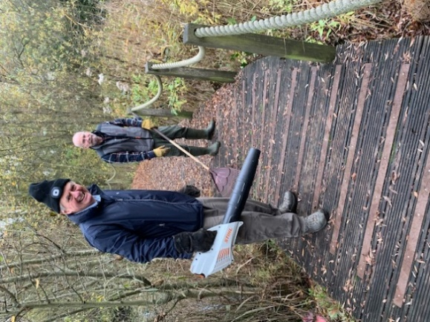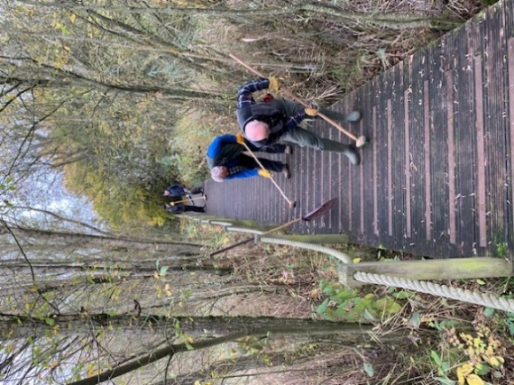
- FINANCE: (Build Back Better Grant & SKPC Budget)

Date | Item | Cost | VAT
 | BUILD BACK BETTER GRANT (£1990)
15 Aug 24 | Deposit on Shed (Master Sheds Gloucester) | 291.67 | 58.33
6 Nov 24 | Shed base timbers and lock (Wickes) | 28.86 | 5.79
6 Nov 24 | 3 bags MOT type 1 (J C Tye) | 11.85 | 2.37
6 Nov 24 | Pond Dipping Nets (NHBS) | 176.65 | 35.33
9 Oct 24 | Wildlife Trail Camera (Concord fotos) | 139.99 | 28.00
27 Jan 25 | Silent Generator (Adrian Collins) | 350.00 | nil
Nov 24 | Balance on Shed (Master Sheds) | 608.33 | 49.67
5 Feb 25 | Vinyl Flooring for shed (Gardiners) | 59.95 | 11.99
5 Feb 25 | Hooks for tools in shed (Gardiners) | 15.79 | 3.16
6 Feb 25 | Gate Counter + 3 yr insurance (Amazon) | 172.83 | 34.57
 | Total expenditure so far | £1855.92
 | 2024/2025 SKPC BUDGET (£1250)
16 July 24 | Mower Service (Mike Parker) | 95.00 | nil
13 July 24 | Plant plugs (Slimbridge) Village Hall stall | 20.00 | nil
18 Sep 24 | Strimming (J Uncles) | 100.00 | nil
Nov 24 | Meadowmania | 83.68 | 3.98
 | Petrol mower/gene | 6.99 | 1.40
7 Feb 24 | Treework (D Isaacs) | 600.00 | nil
 | Total expenditure so far | £905.67

